**QUALITY ASSURANCE MANUAL**

**BEng/BSc/MSc in ?????**

**Department of Electronics**

**University of York**

**Individual/Group Project**

**Document Control**

|  |  |  |  |  |
| --- | --- | --- | --- | --- |
| Version | Modified by | Date | Section modified | Remarks |
| 3.2 | AMT | Oct 2012 | All | Updated |
| 3.3 | GT | Oct 2012 | All | Minor changes and updates |
| 4.0 | NRJ | Oct 2012 | All | Re-worked as an outline generic QA Manual |

**CONTENTS**

1. **INTRODUCTION**
   1. Company Profile ………………………………………………………………………………………………..1
   2. Vision ………………………………………………………………………………………………………………..1
2. **ROLES & RESPONSIBILITIES** 
   1. Organizational Structure…………………………………………………………………………………….2
   2. Group Leader ………………………………………………………………………………………………….3
      1. Role Description……………………………………………………………………………………………3
      2. Risk Management…………………………………………………………………………………………3
      3. QA Metrics……………………………………………………………………………………………………4
   3. QA & Documentation Manager ……………………………..………………………………………5
      1. Role Description……………………………………………………………………………………………5
      2. Risk Management…………………………………………………………………………………………6
      3. QA Metrics……………………………………………………………………………………………………6
   4. Design & Specification Manager ………………………………………………….....…………………7
      1. Role Description……………………………………………………………………………………………7
      2. Risk Management…………………………………………………………………………………………7
      3. QA Metrics……………………………………………………………………………………………………8
   5. Software Manager ……………………………..………………………………………………………….9
      1. Role Description……………………………………………………………………………………………9
      2. Risk Management…………………………………………………………………………………………9
      3. QA Metrics…………………………………………………………………………………………………10
   6. Hardware Manager ……………………………………………………………………………………….11
      1. Role Description…………………………………………………………………………………………11
      2. Risk Management………………………………………………………………………………………11
      3. QA Metrics…………………………………………………………………………………………………12
   7. Testing & Integration Manager ………………………………………………………………………13
      1. Role Description…………………………………………………………………………………………13
      2. Risk Management………………………………………………………………………………………13
      3. QA Metrics…………………………………………………………………………………………………14
   8. Finance Manager ……………………………………………………………………………………………15
      1. Role Description………………………………………………………………………………………15
      2. Risk Management………………………………………………………………………………………15
      3. QA Metrics…………………………………………………………………………………………………16
   9. Marketing Manager …………………………………………………………………………………………17
      1. Role Description …………………………………………………………………………………………17
      2. Risk Management ………………………………………………………………………………………17
      3. QA Metrics …………………………………………………………………………………………………17
3. **DELIVERABLES** …………………..……………………………………………………………………………………….18
4. **PROJECT MANAGEMENT METHODOLOGY**……………………………………………………………....19
   1. Requirements and Specifications Phase …………………………..………………………..19
   2. Design Phase …………………………………………………………………………………………………20
   3. Implementation Phase …………….……………………………………………………………………21
   4. Testing and Integration Phase ………………………………………………………………………..21
   5. Quality Auditing Reviews …………………………………………………………………………………21
5. **Appendix A: Documents Templates** ………………………………………………………………………… 22

Meeting Minutes …………………………………………………………………………………………………………23

Manager Reports ………………………………………………………………………………………………………..23

QA Metric List ……………………………………………………………………………………………………………..24

Implementation Progress Report ………………………………………………………………………………..24

1. **Appendix B: Charting Methodology** ………………………………………………………………………25

Gantt Chart …………………………………………………………………………………………………………………25

1. **INTRODUCTION**
   1. **Company Profile**

The company was set up as Insert appropriate text. Our major business focus is Insert appropriate text. Our design specifications comply with industry standards and our products emphasis is on innovative solutions as well as dedicated product support.

Based in York, we are a team of highly qualified engineers Insert appropriate text explaining what you do to achieve your business aims.

* 1. **Vision**

Is all about defining the purpose of a company by means of it’s values or working methodology. Meant for both external and internal audiences. Example:

* To help Universities provide the best IT environment for their customers and staff by ensuring our service is always delivered by the best qualified people to the latest quality standards
  1. **Mission**

Is all about defining the purpose of a company by means of it’s objectives. Meant largely for internal audience it defines key measures of success. Example:

* “To provide Universities with the best IT solutions on time and on budget achieving minimum 98% customer satisfaction”

1. **ROLES AND RESPONSIBILITIES**
   1. **Organizational Structure**

In order for any group of workers to achieve their set objectives, responsibilities and roles must be well identified. Figure 1 shows an outline structure of a company (although not all of these posts may be occupied at any one time[1] and one person may carry out more than one role). The Group Leader holds the responsibility to ensure the harmony between group members and that company policies and procedures are adhered to by all members of the company. As one goes down in the figure, the roles change into more operational nature, through which the actual products are designed and strategies are applied. Communication between team members is achieved mainly through weekly meetings and review/progress reports. Reviews at each milestone are also critical to evaluate the quality procedures that were followed, and to inspect deliverables for errors and defects. Your management structure may not always look like the model shown in Figure 1 (e.g. you may not need a software manager for your project) – modify it and the role descriptors, risks and metrics that follow to suit your project, group structure and working methodology.

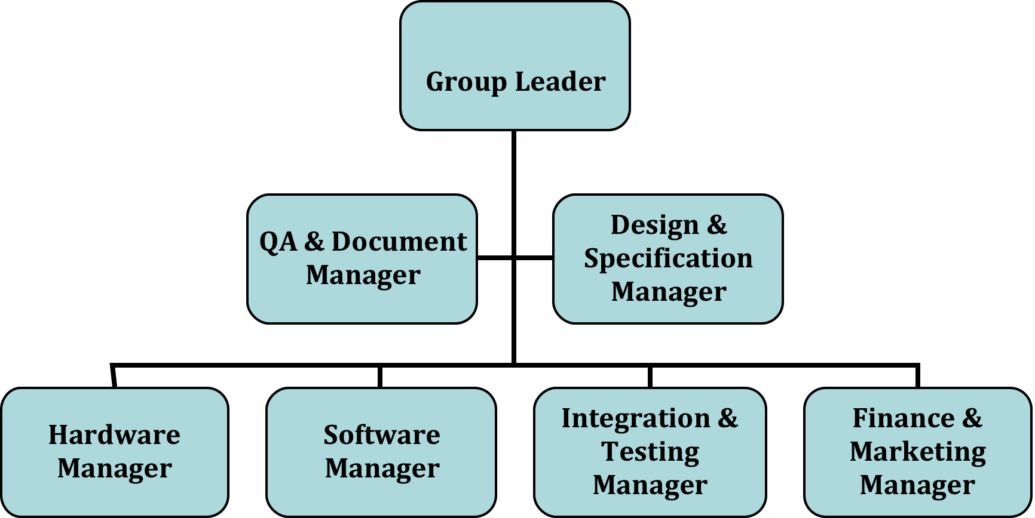

**Figure 1: The structural organization of project group**

* 1. **Group Leader**
     1. **Role Description**

The group leader is responsible for taking an overviewing role within the company and organising the working of the team toward the desired goals. He/she is accountable for insuring that the design and development process runs smoothly during the project life cycle (section 4) until the final product is presented to the customer. Accomplishing this involves several tasks that include:

* Arranging for regular meetings with the team and assigning the Chair in each meeting.
* Provide meeting agendas (see Appendix A for templates).
* Assigning the different roles required in the project in a way that ensures the optimal use of every member’s qualifications is reached.
* Maintaining an encouraging and cooperative environment where every individual contribution is appreciated and respected.
* With the help of the Design & Specification Manager, provide the plans for the project development and monitor the progress.
* With the help of the appropriate managers, provide the timetable plan and ensure it’s met, or make appropriate modifications as required.
* Make sure that the requirements and standards are met at every stage whether during the development process itself or when the final product is near completion.
* Provide solutions and backup strategies as required.
* Grant final approval of all the deliverables provided by the team.
* Deliver reports to customers and act as the connection between them and the project team.
* Produce the overall project plan and time schedule.
  + 1. **Risk Management**

|  |  |
| --- | --- |
| Risk | Possible Solution |
| Some group members don’t get along with each other. | Try to resolve any issues that group members might have. If this does not work, consider assigning tasks to minimise disruption within the group as a whole. |
| The prolonged absence of a member in the group. | Have more then one team member trained to do any task. Be ready to adjust schedules as appropriate. |
| Deadline overdue. | Have regular project plan review meetings where possible overruns can be identified and rescheduling can be considered. |
| Failure to meet one of the requirements. | Have regular review meetings where requirement conformity is checked. Make sure that the design and the development of the product is organized in a way that simplifies rollback and re-implements the missing requirements with as little modification to other parts as possible. |

* + 1. **QA Metrics**

|  |  |
| --- | --- |
| Metric | How measured |
| Client requirements clarity. | Holding regular meetings ensuring that the client understands his/her own requirement statements and that these have been interpreted correctly by the company and finally signed off by both sides. |
| Complete specification. | Checking the specifications against the requirements statement to make sure all requirements are covered by the specifications team, during appropriate review meeting(s). |
| Deadlines met. | Deliverables submitted as timetable and recorded. |

* 1. **QA & Documentation Manager**
     1. **Role Description**

Quality Assurance works through procedures and processes to ensure the products produced by the company are of high quality that meets the customer requirements. The QA manager is responsible for developing processes and procedures that can be followed throughout the complete life cycle of a product to ensure the quality of the product through the adherence of these processes and procedures, including setting up, and monitoring, an appropriate document change management system (see appendix A). Accurately carrying out these sets of processes and checks requires maintaining regular interactions and communications between the QA & Documentation manager and other key members in the project team.

The communication between different members of the group is done mainly through review meetings, regular group meetings, various types of documents and reports that are designed to help members follow the company’s QA procedures and allow the QA & Documentation manager to check such procedures are being followed. As projects progress and experience is obtained QA procedures and process may change, but these changes will only be made after a QA review meeting, the approval of the QA & Documentation manager and Group Leader and following the updating of the appropriate procedure document. Tasks for the QA & Documentation manager include:

* In conjunction with the Group Leader define the quality standards for the company.
* Provide the QA plan that explains what processes should be followed in any project undertaken by the company, who should do it, what procedures and methods should be used, and what standards of quality and performance to follow.
* Specify the QA metrics against which the quality of the result must be measured in each stage of the product development.
* Monitor the use of the QA processes through the collection of QA metrics.
* Provide updated reports to the Group Leader about the system progress and the efficiency in following the quality procedures.
* Carry out Review processes at the end of each development stage to ensure the quality and address any shortfalls in process.
* Specify the different types of documents and reports to be delivered throughout the product life cycle and specify when these should be produced.
* Ensure that all documents follow the standards set by the company, e.g. in term of their style, format, drawing and figure clarity, etc.
* Archive all records related to a project.
* Track all the updates on company documents.
* Monitor documents delivery deadlines.
* Ensure that the most up-to-date versions of all documents are available and used.
* Ensure all meetings are appropriately managed with records taken of proceedings.
* Ensure all actions are completed in a timely and qualitately acceptable way.
  + 1. **Risk Management**

|  |  |
| --- | --- |
| Risk | Possible Solution |
| Missing or corrupted documents. | Have a backup copy whenever any document is added or updated. |
| Failure to carry out a procedure. | Hold regular review meetings to consider QA procedures. Consider QA procedures on a regular basis and assess their appropriateness, updating as required. |
| QA metric not met. | Set up continued monitoring of staff’s adherence to QA procedures and regular, monitored, deadlines for metrics. |
| Incompatibility between two developed modules. | Ensure the most up-to-date versions of all documents are available and used. |

* + 1. **QA Metrics**

|  |  |
| --- | --- |
| Metric | How measured |
| Documents delivered. | Number of documents expected Vs delivered. |
| QA metric collection. | Number of QA metrics met Vs expected. |
| Deadlines met. | Deliverable submission Vs timetabled. |

* 1. **Design & Specification Manager**
     1. **Role Description**

The need to focus on a detailed product design and specification is paramount to the delivery of a high quality end product. To ensure this, a large proportion of the company’s budget goes into the research of the product’s design. Our design team develops novel design concepts and collaborates with the design teams of some of our major clients. We also pride ourselves in knowledge partnerships with the Electronics Department of the University of York.Specific responsibilities of the Design and Specification Manager include:

* Use specialist knowledge to establish requirements for the product from the customer specification.
* Develop design procedures and guidelines to ensure consistency of all design work against these procedures and guidelines.
* Establish procedures for product design, evaluate and develop improved techniques for the control of product designs, quality, reliability and safety.
* Lead/manage delivery of all design work for the company, providing design guidance and feedback to other company departments involved.
* Plan, monitor and control the efficient and cost effective flow of orders through the department and ensure deadlines are met by taking into account design flow priorities, budget and time of production.
* Develop comprehensive creative design development processes, and roll these out across the company, and with suppliers, including clear briefing and signoff guidelines.
* Manage and oversee all roles and activities in the design area of the company.
* In association with the Group Leader, delegate duties when appropriate and monitor individual’s performance so staff are able to perform to a high level of attainment and satisfaction.
* Meet on a weekly basis with the other managers of the company to discuss project progress.
  + 1. **Risk Management**

|  |  |
| --- | --- |
| Risk | Possible Solution |
| Delay in design completion. | Report to the group working on next stage of the project. Consider re-allocation of tasks to conclude critical parts of the design flow. Review why delay has occurred and identify the reasons. |
| Unacceptable error margins on product design specifications. | Communicate with the production team, and recheck the design margins adjusting these where appropriate. |
| Non-conformance of product to stipulated standards. | Identify which part of the product is non-conformant. Analyse and rectify according to the standards. |

* + 1. **QA Metrics**

|  |  |
| --- | --- |
| Metric | How measured |
| Design Cost. | Suitable measure should be chosen, such as time, man-power etc. |
| Design Appropriateness. | Correct translation of specification. |
| Module/Component Interoperability. | Estimate of the cohesion among different components in the design. |
| Defects. | Number of defects identified and stage when identified. |
| Deliverables Submitted/ Reviewed/Accepted/Rejected. | Number and percentage of design elements that are released and related to number that are accepted and rejected. |

* 1. **Software Manager**
     1. **Role Description**

The software manager is responsible for planning, designing and coordinating the implementation of the software components of a project. He/she should have a full understanding of the specifications and the requirements of the project in order to develop the desired product. Also, he/she should be in regular communication with the QA manager to ensure the quality of the software design, as well as with the Hardware Manager to ensure the compatibility between the hardware and software components of the product. The Software Manager tasks should include:

* Develop a clear overall software design based on the specifications and the customer requirements.
* Decide on the methods and the techniques to be used in the design phase.
* Identify the details of the specification, design and implementation, such as the programming language, interfaces, modules, objects, data encapsulation, and hierarchy.
* Monitor the implementation and the coding process.
* Deliver appropriate documents regarding the high-level and low-level designs.
* Make sure the design standards are followed and the procedures are applied to keep consistency between different parts of code generated by different members of the implementation team.
  + 1. **Risk Management**

|  |  |
| --- | --- |
| Risk | Possible Solution |
| Failure of code at some point. | Consider during regular review meeting and assign appropriate manpower to correct failure, based on criticality of code. Cooperate with test and integration manager to provide complete set of test cases. |
| Not compatible with hardware or with other parts of system. | Develop the design in collaboration with specification/design manager and hardware manager to ensure compatibility. |
| Code inconsistency. | Provide specific standards for coding in terms of format, language, naming conventions etc., and keep a reference of all the additions to the code and the relation between them (e.g. in the form of charts and/or class diagrams). |

These issues are to be communicated with the Group Manager and discussed with group members by the earliest to coordinate any rescheduling. The Testing and Integration Manager is also to be notified.

* + 1. **QA Metrics**

|  |  |
| --- | --- |
| Metric | How measured |
| Actual coding time Vs planned. | Register the start and end of coding. |
| Number of actual code lines Vs planned. | Keep count of code lines produced by every member in the implementation team. |
| Comments in code. | Consider line of comments compared to lines of executable code. |
| Compiling errors. | Produce a compilation report to indicate the number of errors during compilation and whether code is error-free and tested. |

* 1. **Hardware Manager**
     1. **Role Description**

The Hardware Manager is responsible for planning, designing and coordinating the implementation of the hardware development for products. He/she should have a full understanding of the specifications and the requirements of the project in order to develop the desired product. Also, he/she should be in regular communication with the QA manager to ensure the quality of the hardware design, as well as with the Software manager to ensure the compatibility between the hardware and software components of the product. Key responsibilities of the Hardware Manager include:

* Develop a clear overall hardware design based on the specifications and the customer requirements.
* Decide on the methods and the techniques to be used in the design phase.
* Identify the details of the specification, design and the implementation details such as the hardware models, interfaces, sub-sections and hierarchy.
* Monitor the implementation and the hardware implementation.
* Assess the quality of the produced hardware.
* Deliver appropriate documents regarding the high-level and low-level designs.
* Make sure the design standards are followed and the procedures are applied to keep consistency between different parts of hardware produced by different members of the implementation team.
  + 1. **Risk Management**

|  |  |
| --- | --- |
| Risk | Possible Solution |
| Failure of hardware at some point. | Consider during regular review meeting and assign appropriate manpower to correct failure, based on criticality of the hardware. Cooperate with Test and Integration manager to provide complete set of test cases. |
| Not compatible with software or with other parts of system. | Develop the design in collaboration with specification/design manager and software manager to ensure compatibility. |
| Hardware inconsistency. | Provide specific standards for hardware in terms of format, design models, naming conventions etc., and keep a reference of all the additions to the hardware design and the relation between them (e.g. in the form of state machine). |

These issues are to be communicated with the Group Manager and discussed with group members by the earliest to coordinate any rescheduling. The Testing and Integration Manager are also to be notified.

* + 1. **QA Metrics**

|  |  |
| --- | --- |
| Metric | How measured |
| Number of modules successfully implemented as compared to the total number of modules. | Keep record of number of modules implemented successfully. |
| Number of specifications met as compared to specifications assigned. | Measure specifications successfully met, appropriately, and compare to original specification. |
| Number of bugs and errors in hardware compilation. | Measure during implementation. |
| Actual coding time (FPGA’s for example) as a percentage of planned coding time. | Keep record of coding time and compare when modules completed with planned time. |

* 1. **Testing & Integration Manager**
     1. **Role Description**

The responsibility of the Testing and Integration manager is to manage the procedures involved with the testing and integration phases of a project. He/She should have a holistic view of the testing and integration phase in order to competently perform their responsibility. The main role of the integration and testing manager is to make an effective plan for integration and testing of the project. Integration and testing Gantt charts must be produced to show how the plans are scheduled. An example of integration and testing Gantt chart is shown in Appendix B. In relation with the Gantt chart, the tasks can be assigned to group members and results from team members collected at the appropriate deadline. The results will be collected by the integration and testing manager for them to produce testing and integration reports. The integration and testing manager should also produce test sheets for all team members to use during implementation stages of a project. These should be collected by the integration and testing manager and reports produced based on these completed sheets. An example testing report is included in Appendix A. The report will be delivered to the Group Leader for input to review meetings. The key responsibilities of the integration and testing manager include:

* Manage the procedures in the testing and integration phases.
* Make an effective integration and testing plan.
* Represent and schedule the plan by producing integration and testing Gantt chart.
* Assign tests to team members according to schedules as outlined in the project Gantt chart.
* Collect results from team members at the deadlines request.
* Produce testing and integration reports.
  + 1. **Risk Management**

|  |  |
| --- | --- |
| Risk | Possible Solution |
| Implementation phase overdue. | Reschedule integration and testing plan. |
| Any part of testing and integration overdue. | Report the reasons for overrun and also reschedule integration and testing plan. |
| Error occurs, but cannot find which part of design is the problem. | Communicate with Software and Hardware managers to identify the exact problem. |
| Significant issues related to the integration of one or more modules. | Communicate issues with Software and/or Hardware managers to fix problem. |
| Modules developed to out-of-date module specification and/or design documents. | Ensure the most up-to-date versions of all documents are available and used. |

These issues are to be communicated with the Group Leader and discussed with group members by the earliest to coordinate any rescheduling. The Software and Hardware managers are also to be notified.

* + 1. **QA Metrics**

|  |  |
| --- | --- |
| Metric | How measured |
| Integration plan followed. | Monitor and assess integration throughout the project time. |
| Testing plan followed. | Monitor and assess testing procedures followed throughout the project time. |
| Number of modules tested. | Collected from test reports. |
| Errors and time to fix these. | Collected from test reports. |

* 1. **Finance Manager**
     1. **Role Description**

Key to the success of the company is a competent finance team. The finance team will take responsibility for organizing the financial and accounting affairs. Some of the key duties of the Finance Manager include:

* Provide and interpret financial information such as cost/benefit analyses, Profit & Loss Accounts, Balance Sheets etc.
* Monitor and interpret cash flows and predict future trends.
* Analyse change and advise Group Leader accordingly.
* Formulate strategic and long-term business plans.
* Research and report on factors influencing business performance.
* Analyse competitors and market trends.
* Develop financial management mechanisms that minimise financial risk.
* Conduct reviews and evaluations for cost-reduction opportunities.
* Manage a company's financial accounting, monitoring and reporting systems.
* Liaise with auditors to ensure annual monitoring is carried out.
* Develop external relationships with appropriate contacts e.g. auditors, solicitors, bankers and statutory organizations such as the Inland Revenue.
* Produce accurate financial reports to specific deadlines.
* Manage budgets.
* Arrange new sources of finance for a company's debt facilities.
* Keep abreast of changes in financial regulations and legislation.
  + 1. **Risk Management**

|  |  |
| --- | --- |
| Risk | Possible Solution |
| Credit risk. | Make detailed contracts with customers. |
| Liquidity risk. | Make an accurate budget and monitor during project lifecycle. |
| Poor budgeting. | Monitor at regular intervals and adjust as necessary. |

* + 1. **QA Metrics**

|  |  |
| --- | --- |
| Metric | How measured |
| Assets turnover. | Sales/Average total assets.  Measure the efficiency of the company’s use of its money. |
| Economic value added. | Net operating profit after taxes – cost.  Help determine created value. |
| Debt to equity ratio. | Debit/Equity.  Limit the ratio to less than 1 helps earn profit. |
| Return on Investment (ROI). | Optimise the efficiency at each stage. |
| Total Cost of Ownership (TCO). | Consider all costs, including energy, training, maintenance, rent etc. |

* 1. **Marketing Manager**
     1. **Role Description**

A dynamic marketing plan is crucial in keeping the company brand in demand and staying ahead of the competition. The marketing arm will concern itself with promoting the sales of the product/service range. Key roles of the Marketing Manager include:

* Research and evaluate new product/service opportunities, demand for potential products/services, and customer needs and insights.
* Define overall marketing strategy/execution plans for existing products/services.
* Work with the product/service development team to manage new product or service development.
* Manage launch campaigns for new products/services.
* Manage distribution channels for products/services.
* Ensure effective, branded marketing communications including the company website, print communication, and advertising.
* Manage media and marketing staff and external PR agencies.
* Analyse the effectiveness of all marketing efforts.
* Define the target market for new products and set the pricing.
* Explore appropriate business models for sales of new products/services.
  + 1. **Risk Management**

|  |  |
| --- | --- |
| Risk | Possible Solution |
| Market access. | Gain authorisation from certification bodies as required.  Check whether end users are those with purchasing authority, model selling strategy accordingly. |
| Pricing issues related to core products/services. | Find trusted sources with appropriate pricing. |
| Competition. | Ensure quality of products/services.  Produce appropriate advertising campaign.  Provide excellent after-sales service. |

* + 1. **QA Metrics**

|  |  |
| --- | --- |
| Metric | How measured |
| Brand awareness. | Market survey. |
| Customer satisfaction. | Customer feedback. |
| Share of the market. | Market research. |

1. **DELIVERABLES**

The following list is only a template to modify depending upon your own project. Therefore, some will be relevant and kept, others will not and thus deleted and others will need to be inserted into the table. Your project brief will inform the actual deliverable requirements.

**Table 1:** **list of deliverables expected throughout the project**

|  |  |  |  |
| --- | --- | --- | --- |
| **Deliverable** | **Producer** | **Recipient** | **Due** |
| **QA Plan** | QA manager  + managers | All company personnel | On company establishment |
| **Requirements Statement** | Client | Group Leader +  Design & Spec manager  + QA & Docs manager | Beginning of project |
| **Product/Service Specification** | Design & Spec manager | Project team | End of spec phase |
| **Schedule Plan** | Group Leader | Project team | End of spec phase |
| **Design Specifications** | Software manager  + Hardware manager | Spec manager  + QA manager | Design phase |
| **Integration &Testing Plan** | Testing & Integration manager | Testing team | Before implementation starts (Testing plan) & Implementation phase (Integration plan) |
| **QA Auditing Reports** | QA & Docs manager | Group Leader | Throughout development process |
| **S/W & H/W components** | Implementation team | Software manager  + Hardware manager | Specified milestones |
| **Test Results and Acceptance Reports** | Testing & Integration manager.  Client | Design & Spec manager  + QA & Docs manager  Group Leader | Integration phase  + End of project development |
| **QA Metrics** | QA & Docs manager | Project team | End of Design phase |
| **Budget Analysis Reports** | Finance manager | Group Leader | Beginning of project |

|  |  |  |  |
| --- | --- | --- | --- |
| **Costs, expenses and resource reports** | Finance manager | Group Leader | Throughout project |
| **Progress reports** | Project managers | Group Leader | Throughout project |
| **Meeting agenda** | Group Leader | Project managers | Prior to meeting |
| **Meeting minutes** | Meeting chairman | Project managers | After meeting |

**PROJECT MANAGEMENT METHODOLOGY**

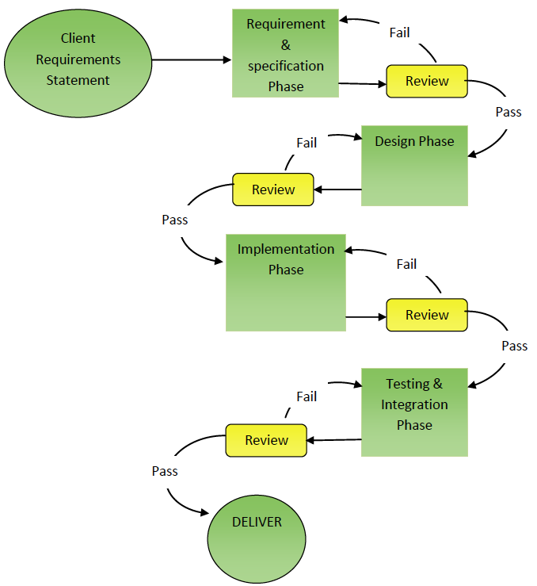

**Figure 2: Project Life Cycle**

* 1. **Requirements and Specifications Phase**

Projects will usually start with a statement made by the customer to explain what he/she requires of the project. This is then followed by a thorough requirements capture analysis, undertaken by the company, to produce a detailed document of the specifications of the project. Any inconsistencies or inaccuracies between the specification and requirements should be identified at this stage and discussed with the client as this will form the basis to start the design phase of the project. To summarise the basic steps:

* The client provides a statement to the company of what the project must do.
* The Group Leader with the Design & Specifications manager and the QA & Documentation manager analyse the requirements statement. They outline the functionality of the product/service and identify whether all the requirements are specified and appropriate. They check for any inconsistent or incorrect requirements as well as any unnecessary ones that can be eliminated without affecting the functionality. An estimated budget can also be derived at this stage and the complete product/service feasibility is predicted (Go/No go).
* The Group Leader should report to the client and discuss any changes made to the requirements to gain client sign off – including any additional budget.
* Once a contract is agreed, the Design & Specification manager generates a specification document, and the Group Leader, in consultation with their managers and Client will create the project time schedule.
* The Design & Specification manager should then meet with the managers of each stage of the development process (usually through Review meetings) and provide them with the specification document and start the implementation phase of the project.

The techniques to be used to generate the specifications document are dependent upon your project and you must select an appropriate working methodology thus there are no prescribed models included in this outline.

* 1. **Design Phase**

As soon as the specifications document is finalised, the appropriate managers, possibly under the supervision of the Design & Specification manager, should start to design the method of realising the project deliverables. They should think of *how* the requirements must be implemented. Since the project might have both hardware and software components, managers will work together to produce a compatible overall design. They must then generate a Design Specification document. There may be a need for individually focussed or Internal Design Specification documents, which are aimed at the appropriate teams. These should contain more detail regarding the specifications and functionalities of specific project components and how they should be implemented.

* 1. **Implementation Phase**

Related to the Design Specification and Internal Design Specification documents, the appropriate managers will analyse the design and consider appropriate time schedules and resource requirements for the project components. Tasks will be assigned to project team members respectively. Each sub-team will work on the appropriate tasks according to needs taken from the specification. If your project brief requires a finished product then this implementation phase will need to be monitored and controlled usually via regular review meetings. Change management techniques and QA version control will be required if unforeseen problems occur leading to possible rescheduling of the implementation plan. Communication with all appropriate stakeholders is paramount at these points. When each individual component is finished, the respective managers are responsible for testing and delivery to the Testing and Integration manager. Changes may affect timescales, resources and thus budgets so the Finance manager will also need to be kept in the loop.

* 1. **Testing and Integration Phase**

The actual testing and integration phase may not be required if you are producing a proof of concept report or providing a report on technology options. If there is a need to actually produce a product or service offering then the respective components of the project should be tested and integrated during this phase. This is a critical phase in the project lifecycle. The testing and integration manager is responsible for the procedures in this phase of the product cycle. Basic functionality must be tested at all points of the integration cycle as or when components are integrated together. Integration strategy is for you or your team to determine but where appropriate you must produce test and integration reports that record the details of successful component tests and any errors encountered. Any errors will likely involve iteration back to an earlier phase of the cycle therefore there may be a need for regression testing to be adopted at the end of this phase.

**4.5. Quality Auditing Reviews**

Generating quality products/services cannot be accomplished without an appropriate process of the same high quality. The procedures used to conduct each of the aforementioned design and implementation phases are designed to meet these standards. A systematic method of evaluating the quality of every deliverable and output, as well as supervising QA metric collection, is one of the main purposes of the review sessions shown in Figure 2 (Page 19). Passing a review session is a *MUST* to carry out the next step in a project. The output of review sessions is a *Quality Auditing Report* submitted to the Group Leader. No further development can take place without the approval of the QA & Documentation manager and Group Leader and to the satisfaction of the review team. If the review team is not happy, the process will be rolled back to the last successful review to find the problem and an appropriate solution.

**Appendix A: Documents Templates**

The documents in any project are as important as any other part of it. Therefore, they must be standardized to insure better quality. Some of the standards used in the company are:

* All documents must have cover page, with the title of the document, the date, the author, and the company logo.
* All pages must be numbered in the lower right corner, and the lower left corner must contain the document title.
* Titles and subtitles must be of bold font size 14.
* Text must be of font size 12.
* All documents must include an updated history table, specifying version number, modification date, modifier name, sections and a remarks section.

**Configuration Change Management**

It is crucial in any project, and even more so in a project involving more than one person, that the most up-to-date documents are used when changes are made and that it is possible to follow the history of a particular document (document here can mean reports, audits, software code, design documents, hardware designs, in fact anything the company produces). To do this a company will put in place a configuration change management system. In its simplest form this will mean that every document will have a *Name* (in the case of this document ‘QAM’) and one or more *Numbers* after this name representing the version of that particular document. In the case of this document this is ‘4.0’ where ‘4’ indicates the fourth major release of the document ‘QAM’ and ‘0’ indicates that no minor revisions have yet taken place. When changes are made to documents the name will stay the same but the numbers will change. In addition, a short note at the start of the document should summarise what has been changed between the current and previous versions (see the beginning of this document under Document Control).

Some example templates are produced below for you to use or modify to your own standard – remember to use the same template format each time you need it, even if some parts are left blank for that particular time.

**Meeting Minutes**

Meeting :#

Week:

Date:

Course: MSc in Digital Systems Engineering

Group :

Members:

Agenda

1. Apologies for absence:
2. Actions from last meeting:
3. Specific items for this meeting:
4. Next meeting date & time:

**__________________________________________________________________**

**[Manager] Reports**

Report number:

Circulation list:

Report author:

Date:

1. Description and purpose of the report
2. Body of report
3. Comments/discussion points/recommendations

**QA Metric List**

Project:

Report Title:

Circulation list:

Author:

Date:

|  |  |  |  |  |
| --- | --- | --- | --- | --- |
| Metric | How measured | Produced by | Date | Results & remarks |
|  |  |  |  |  |
|  |  |  |  |  |

Comments/discussion points/recommendations

**Implementation Progress Report**

Project:

Report Title:

Circulation list:

Author:

Date:

|  |  |  |  |  |
| --- | --- | --- | --- | --- |
| Component or task | Start date | Progress details | % complete | Expected finish date |
| Insert here the name of the component you are working on | The date you started the work | Details of what you did, any problems encountered, what still needs to be done |  |  |

Comments/discussion points/recommendations

**Appendix B: Charting methodology**

**Gantt Chart example.**

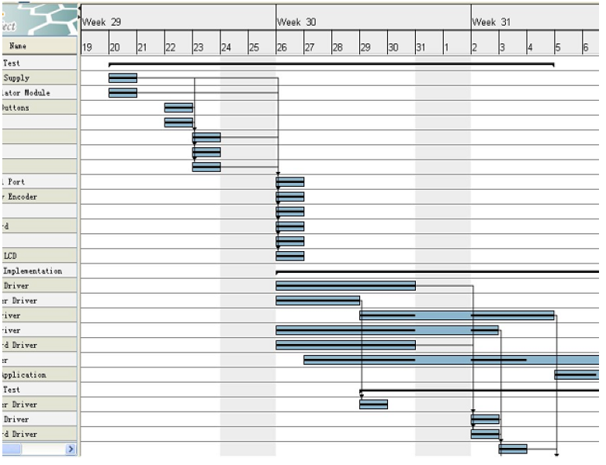

1. It should be realized that whilst not all of these posts need to be occupied all the time, the functions as described in the role descriptions of each post do need to be kept in mind in all aspects of the project.